****Pestaña 1 – Home

**WELCOME**

**-------------------------------------------------------**

**2nd INTERNATIONAL CONFERENCE ON APPLIED AND COMPUTATIONAL MATHEMATICS – ICACM S 2024**

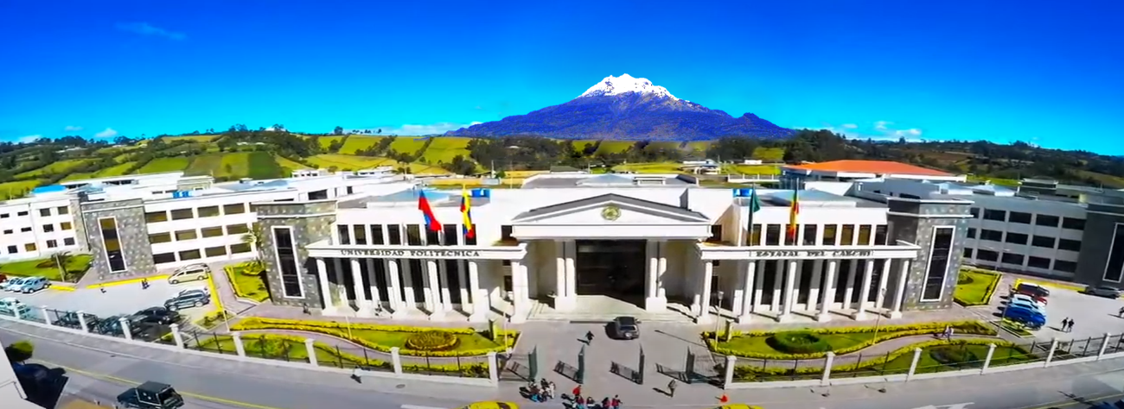Banner2



**DATES: 29, 30 Y 31 May 2024**

**About us:**  
The ICACM 2024S aims to provide a main forum for students in applied mathematics and computer science to exchange ideas, discuss trends and challenges in these fields, present their latest developments and research, and establish contacts for future collaborations.



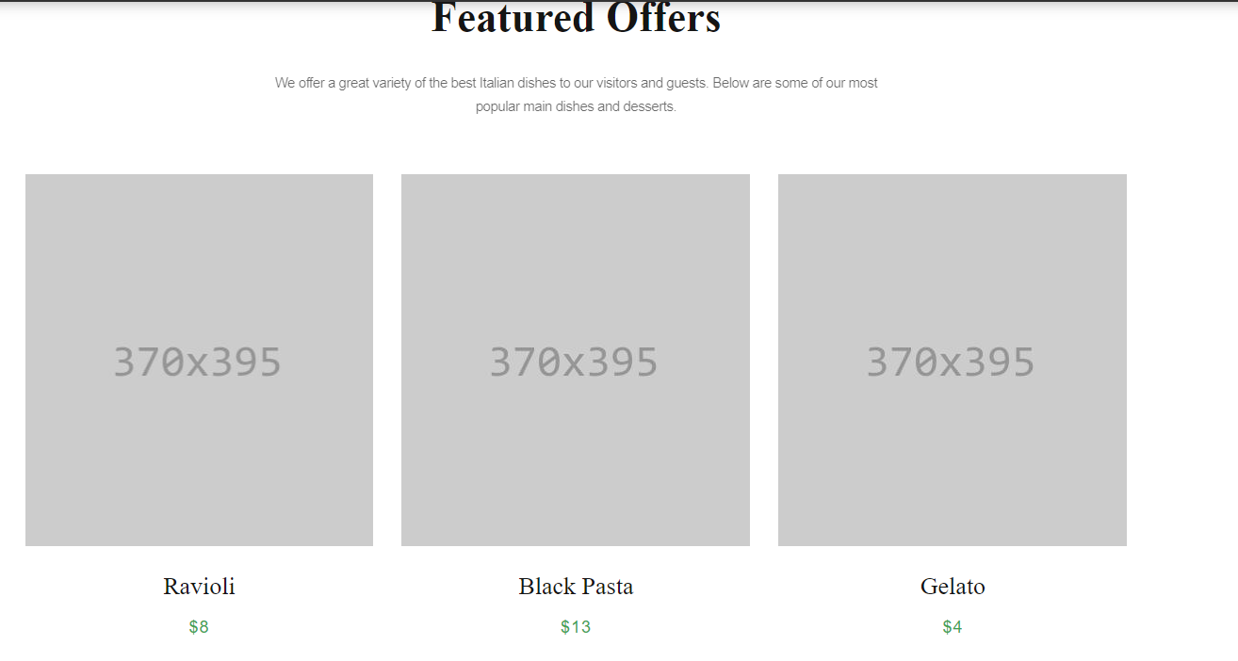

**Organizers**

**We appreciate the universities that collaborated in the planning and execution of this project.**

LogoYacha1

LogoUpec1



Universidad Yachay Tech

Universidad Politécnica Estatal Del Carchi

Puede ir los links web de cada U (Revisaras los lineamientos de los logos de la Yachay)

<https://upec.edu.ec>

<https://www.yachaytech.edu.ec>

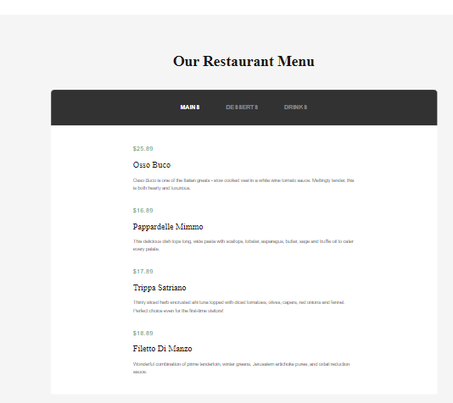

Esta parte sería bueno, poner algunas ponencias con títulos, pero no tengo nombres ni títulos todavía, lo puedes sacar ahora?

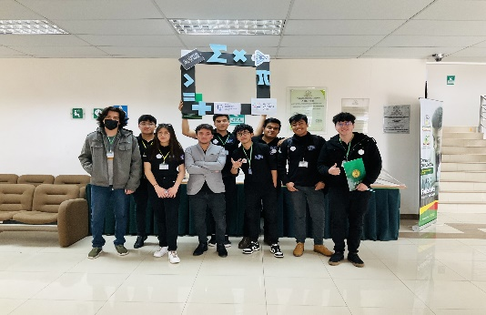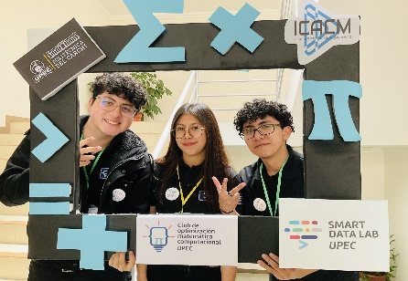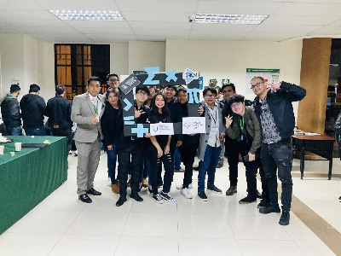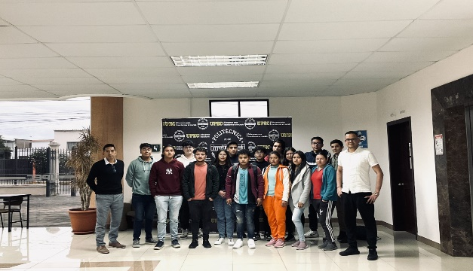

Pestaña 2 – About us



Banner1

ICACM 2024S will allow Universidad Politécnica del Carchi and Yachay Tech University to consolidate their position in the field of applied mathematics and computer science, and strengthen their relationships with other universities.

Universities Honoring Us with Their Attendance



[Universidad Machala](https://www.google.com/url?sa=t&rct=j&q=&esrc=s&source=web&cd=&ved=2ahUKEwjx2fXj5M6FAxW8bDABHQVKAvYQFnoECAgQAQ&url=https%3A%2F%2Fwww.espe.edu.ec%2F&usg=AOvVaw3JJnKpiQbAXniRV9_RRL9X&opi=89978449)

### [Universidad de las Fuerzas Armadas](https://www.google.com/url?sa=t&rct=j&q=&esrc=s&source=web&cd=&ved=2ahUKEwjx2fXj5M6FAxW8bDABHQVKAvYQFnoECAgQAQ&url=https%3A%2F%2Fwww.espe.edu.ec%2F&usg=AOvVaw3JJnKpiQbAXniRV9_RRL9X&opi=89978449)

Escuela Superior Politécnica Agropecuaria de Manabí "Manuel Félix López

ESPAM

UDENAR

[Universidad de Nariño](https://www.google.com/url?sa=t&rct=j&q=&esrc=s&source=web&cd=&ved=2ahUKEwjx2fXj5M6FAxW8bDABHQVKAvYQFnoECAgQAQ&url=https%3A%2F%2Fwww.espe.edu.ec%2F&usg=AOvVaw3JJnKpiQbAXniRV9_RRL9X&opi=89978449)

[Universidad](https://www.google.com/url?sa=t&rct=j&q=&esrc=s&source=web&cd=&ved=2ahUKEwjx2fXj5M6FAxW8bDABHQVKAvYQFnoECAgQAQ&url=https%3A%2F%2Fwww.espe.edu.ec%2F&usg=AOvVaw3JJnKpiQbAXniRV9_RRL9X&opi=89978449)**[Técnica de Manabí](https://www.google.com/url?sa=t&rct=j&q=&esrc=s&source=web&cd=&ved=2ahUKEwjx2fXj5M6FAxW8bDABHQVKAvYQFnoECAgQAQ&url=https%3A%2F%2Fwww.espe.edu.ec%2F&usg=AOvVaw3JJnKpiQbAXniRV9_RRL9X&opi=89978449)**

UTMACH

[Universidad de Ambato](https://www.google.com/url?sa=t&rct=j&q=&esrc=s&source=web&cd=&ved=2ahUKEwjx2fXj5M6FAxW8bDABHQVKAvYQFnoECAgQAQ&url=https%3A%2F%2Fwww.espe.edu.ec%2F&usg=AOvVaw3JJnKpiQbAXniRV9_RRL9X&opi=89978449)

### [Universidad de las Fuerzas Armadas](https://www.google.com/url?sa=t&rct=j&q=&esrc=s&source=web&cd=&ved=2ahUKEwjx2fXj5M6FAxW8bDABHQVKAvYQFnoECAgQAQ&url=https%3A%2F%2Fwww.espe.edu.ec%2F&usg=AOvVaw3JJnKpiQbAXniRV9_RRL9X&opi=89978449)

UTA

[Universidad técnica del Norte](https://www.google.com/url?sa=t&rct=j&q=&esrc=s&source=web&cd=&ved=2ahUKEwjx2fXj5M6FAxW8bDABHQVKAvYQFnoECAgQAQ&url=https%3A%2F%2Fwww.espe.edu.ec%2F&usg=AOvVaw3JJnKpiQbAXniRV9_RRL9X&opi=89978449)

### [Universidad de las Fuerzas Armadas](https://www.google.com/url?sa=t&rct=j&q=&esrc=s&source=web&cd=&ved=2ahUKEwjx2fXj5M6FAxW8bDABHQVKAvYQFnoECAgQAQ&url=https%3A%2F%2Fwww.espe.edu.ec%2F&usg=AOvVaw3JJnKpiQbAXniRV9_RRL9X&opi=89978449)

UTN

[Universidad Nacional de educación](https://www.google.com/url?sa=t&rct=j&q=&esrc=s&source=web&cd=&ved=2ahUKEwjx2fXj5M6FAxW8bDABHQVKAvYQFnoECAgQAQ&url=https%3A%2F%2Fwww.espe.edu.ec%2F&usg=AOvVaw3JJnKpiQbAXniRV9_RRL9X&opi=89978449)

### [Universidad de las Fuerzas Armadas](https://www.google.com/url?sa=t&rct=j&q=&esrc=s&source=web&cd=&ved=2ahUKEwjx2fXj5M6FAxW8bDABHQVKAvYQFnoECAgQAQ&url=https%3A%2F%2Fwww.espe.edu.ec%2F&usg=AOvVaw3JJnKpiQbAXniRV9_RRL9X&opi=89978449)

UNAE

UDA

[Universidad](https://www.google.com/url?sa=t&rct=j&q=&esrc=s&source=web&cd=&ved=2ahUKEwjx2fXj5M6FAxW8bDABHQVKAvYQFnoECAgQAQ&url=https%3A%2F%2Fwww.espe.edu.ec%2F&usg=AOvVaw3JJnKpiQbAXniRV9_RRL9X&opi=89978449)**[del Azuay](https://www.google.com/url?sa=t&rct=j&q=&esrc=s&source=web&cd=&ved=2ahUKEwjx2fXj5M6FAxW8bDABHQVKAvYQFnoECAgQAQ&url=https%3A%2F%2Fwww.espe.edu.ec%2F&usg=AOvVaw3JJnKpiQbAXniRV9_RRL9X&opi=89978449)**

UTM

[Universidad de las Fuerzas Armadas](https://www.google.com/url?sa=t&rct=j&q=&esrc=s&source=web&cd=&ved=2ahUKEwjx2fXj5M6FAxW8bDABHQVKAvYQFnoECAgQAQ&url=https%3A%2F%2Fwww.espe.edu.ec%2F&usg=AOvVaw3JJnKpiQbAXniRV9_RRL9X&opi=89978449)

### [Universidad de las Fuerzas Armadas](https://www.google.com/url?sa=t&rct=j&q=&esrc=s&source=web&cd=&ved=2ahUKEwjx2fXj5M6FAxW8bDABHQVKAvYQFnoECAgQAQ&url=https%3A%2F%2Fwww.espe.edu.ec%2F&usg=AOvVaw3JJnKpiQbAXniRV9_RRL9X&opi=89978449)

ESPE

Links de cada U e institución.

<https://www.espe.edu.ec/>

<https://www.utm.edu.ec/>

<https://www.uazuay.edu.ec/>

[https://unae.edu.ec/](https://unae.edu.ec/inicio/)

<https://www.utmachala.edu.ec/>

<https://www.utn.edu.ec/>

[https://www.uta.edu.ec/](https://www.uta.edu.ec/v4.0/?page=4)

<https://www.udenar.edu.co/>

<https://www.espam.edu.ec/>